My research explores statistics of nodal domains in high energy eigenfunctions of the Helmholtz equation on “chaotic” domains. Chaotic domains have non-integrable dynamics of a point particle (“billiard ball”) bouncing inside the domain. These high energy eigenfunctions (Fig. 1) arise as vibrational modes of a drum head as well as solutions of the Schrodinger equation for a particle in a “box.” They have applications in acoustics, engineering, data analysis, and address fundamental questions in the mathematical physics area of “quantum chaos.” For non-integrable domains we must deal with boundary conditions for which we cannot find an exact solution to the Helmholtz equation. These types of boundary conditions are interesting because they produce highly complex eigenfunctions at high energies.
This project aims to develop novel computational methods to collect eigenfunctions and compute properties of their nodal domains in order to test certain conjectures from the field of quantum chaos. Tools have already been develop which attain higher accuracy on more data than anything else to date. We propose to finish the development of these tools.
Given an eigenfunction we define a nodal domain of that function to be a connected subset of its domain such that the value of the function has the same sign for all points in the nodal domain. Thus for any function, we can divide the domain of the function into a collection of nodal domains. Bogolmony and Schmidt have conjectured that nodal domains in a chaotic system follow the same statistics as nodal domains in a random plane wave model. They give precise numerical predictions for the asymptotic (high energy) behavior of the average number and boundary length of nodal domains.
The goal of my research is to validate these conjectures using high-precision numerical techniques. Vergini has devised an efficient way to compute solutions of the Helmholtz equation over non-integrable domains which has been implemented in C by Alex Barnett. Since these eigenfunctions have very fine spatial oscillations at high energies, the cost of computing these solutions rapidly increases with higher resolution. Thus we are constrained to work with solutions on a coarsely sampled grid. Using only coarse sampling can result in situations when the boundaries of nodal domains becomes ambiguous (fig. 2). In order to resolve these ambiguities we will adaptively interpolate the numerical solutions around such regions. This interpolation will be done using an expansion in Bessel functions, which span the solution space of the Helmholtz equation.
Significant progress has been made in overcoming computational challenges. I have written efficient C code which counts nodal domains on grids. Key goals for the future are integrating adaptive interpolation into the existing code and finally collecting large-scale data on nodal statistics by running my code on a cluster.
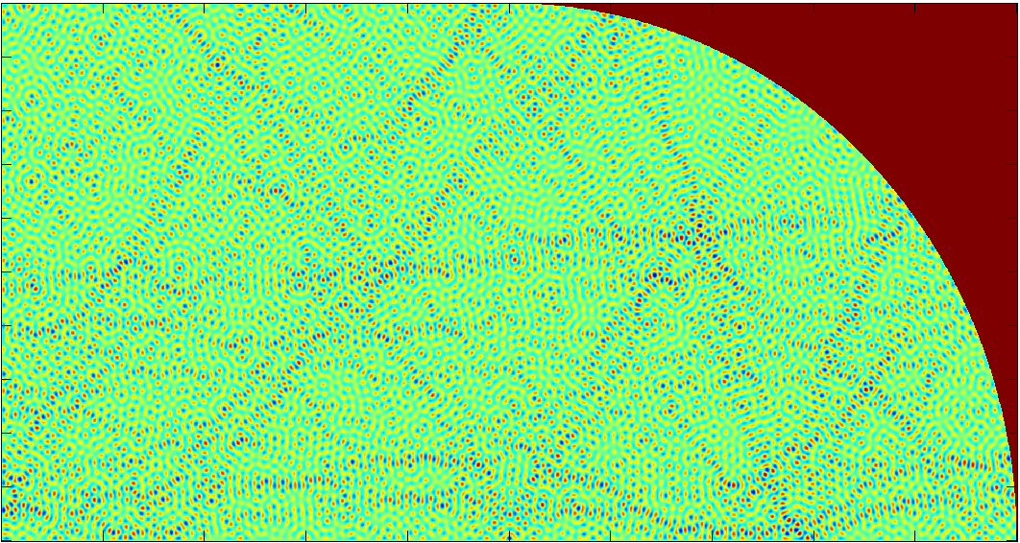Fig. 1: High energy eigenfunction in a quarter stadium.
Fig. 2: Nodal domain ambiguity due to coarse sampling and resolution at finer sampling.

